Prof R. Madana Mohana
BIG DATA ANALYTICS LAB
Exp-2. Develop the following application using Mapreduce

(iii) Real world case studies on MapReduce applications: Uber data analysis

Date: 01-02-2025

To implement Uber Data Analysis using MapReduce in a Hadoop environment on a single-node cluster, you can follow the steps below.

The process involves writing Python code that will be used to perform the Map and Reduce operations on the Uber data.

The Uber dataset contains the following columns:

Date/Time: The date and time of the Uber trip.
Lat: Latitude of the pickup location.
Lon: Longitude of the pickup location.
Base: The base code of the Uber trip.

hadoop@ubuntu22:~$ cd Desktop/RMMBDALAB/MapReduce/UberData_Analysis

hadoop@ubuntu22:~/Desktop/RMMBDALAB/MapReduce/UberData_Analysis$ ls

'MapReduce Ubder data step wise execution 28-08-24.txt'
output_uber_trip_counts_per_date.csv
output_uber_trip_counts_per_date.txt
uber_data.csv
uber_data_large.csv
'Uber data_mapredcue executed steps 01-02-2025.docx'
uber_mapper.py
uber_reducer.py

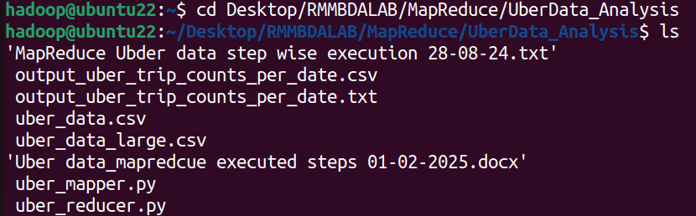

hadoop@ubuntu22:~/Desktop/RMMBDALAB/MapReduce/UberData_Analysis$ cat uber_data.csv

Date/Time,Lat,Lon,Base
04-01-2014 00:11,40.769,-73.9549,B02512
04-01-2014 00:17,40.7267,-74.0345,B02512
04-01-2014 00:21,40.7316,-73.9873,B02512
04-01-2014 00:28,40.7588,-73.9776,B02512
04-01-2014 00:33,40.7594,-73.9722,B02512
04-01-2014 00:33,40.7383,-74.0403,B02512
04-01-2014 00:39,40.7223,-74.0423,B02512
04-01-2014 00:45,40.7505,-73.9946,B02512

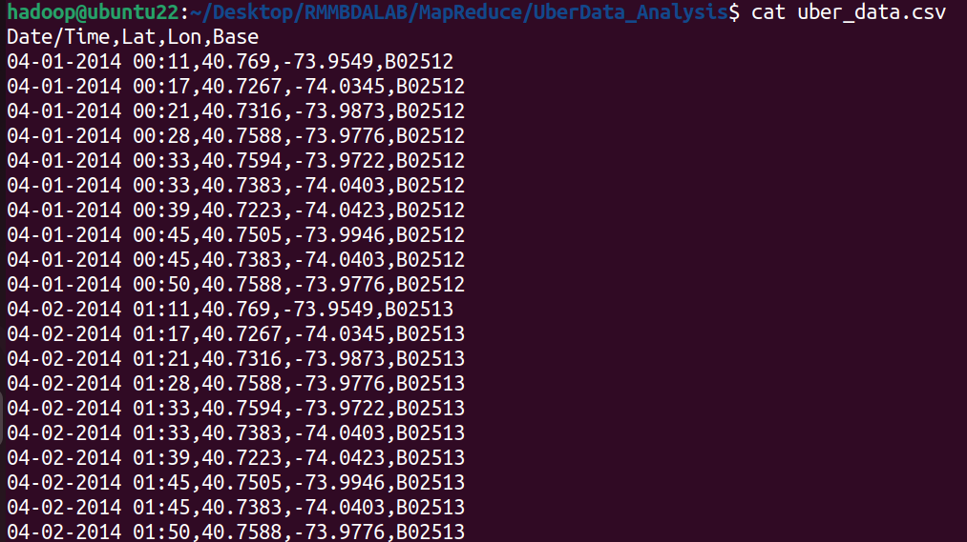

hadoop@ubuntu22:~/Desktop/RMMBDALAB/MapReduce/UberData_Analysis$ cat uber_data_large.csv

Date/Time,Lat,Lon,Base
04/24/2014 16:48:41,40.6877,-74.0178,B02512
04/15/2014 10:26:04,40.5241,-74.0291,B02515
04-01-2014 17:28,40.5611,-73.85,B02512
04-08-2014 02:08,40.8473,-73.963,B02513
04/14/2014 06:23:53,40.5253,-73.9258,B02514
04/15/2014 13:27:52,40.6855,-73.9205,B02514
04/26/2014 20:48:59,40.7212,-73.8979,B02512
04/25/2014 12:08:14,40.6829,-74.0588,B02515
04/29/2014 09:35:25,40.5232,-73.9532,B02512
04-02-2014 06:10,40.956,-73.7856,B02515
04-02-2014 15:23,40.7856,-73.8671,B02512

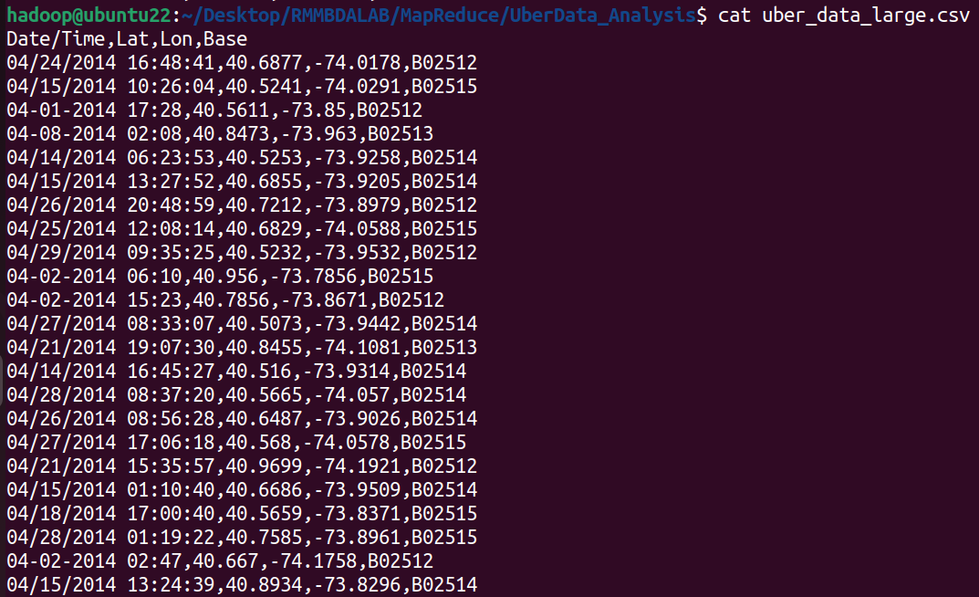

Running Mapper code in Local File System:

hadoop@ubuntu22:~/Desktop/RMMBDALAB/MapReduce/UberData_Analysis$ python3 uber_mapper.py <uber_data.csv

04-01-2014 1
04-01-2014 1
04-01-2014 1
04-01-2014 1
04-01-2014 1
04-01-2014 1
04-01-2014 1
04-01-2014 1
04-01-2014 1
04-01-2014 1
04-02-2014 1
04-02-2014 1
04-02-2014 1
04-02-2014 1
04-02-2014 1
04-02-2014 1
04-02-2014 1
04-02-2014 1
04-02-2014 1
04-02-2014 1
hadoop@ubuntu22:~/Desktop/RMMBDALAB/MapReduce/UberData_Analysis$

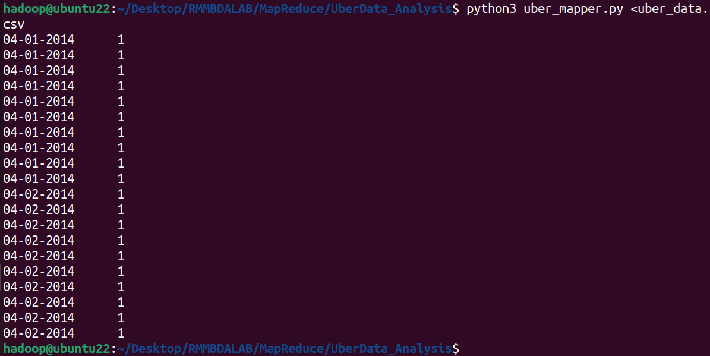

Running Mapper and Reducer together in Local File System:

hadoop@ubuntu22:~/Desktop/RMMBDALAB/MapReduce/UberData_Analysis$ cat uber_data.csv | python3 uber_mapper.py | sort -k1,1 | python3 uber_reducer.py

04-01-2014 10
04-02-2014 10

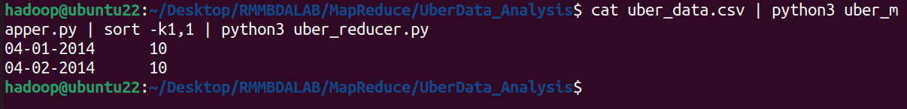
Running Mapper and Reducer in Local file system for the uber large dataset:

hadoop@ubuntu22:~/Desktop/RMMBDALAB/MapReduce/UberData_Analysis$ cat uber_data_large.csv | python3 uber_mapper.py | sort -k1,1 | python3 uber_reducer.py

04-01-2014 23
04-02-2014 23
04-03-2014 19
04-04-2014 15
04-05-2014 16
04-06-2014 15
04-07-2014 13
04-08-2014 20
04-09-2014 13
04-10-2014 16
04-11-2014 15
04-12-2014 11
04/13/2014 8
04/14/2014 19
04/15/2014 21
04/16/2014 14

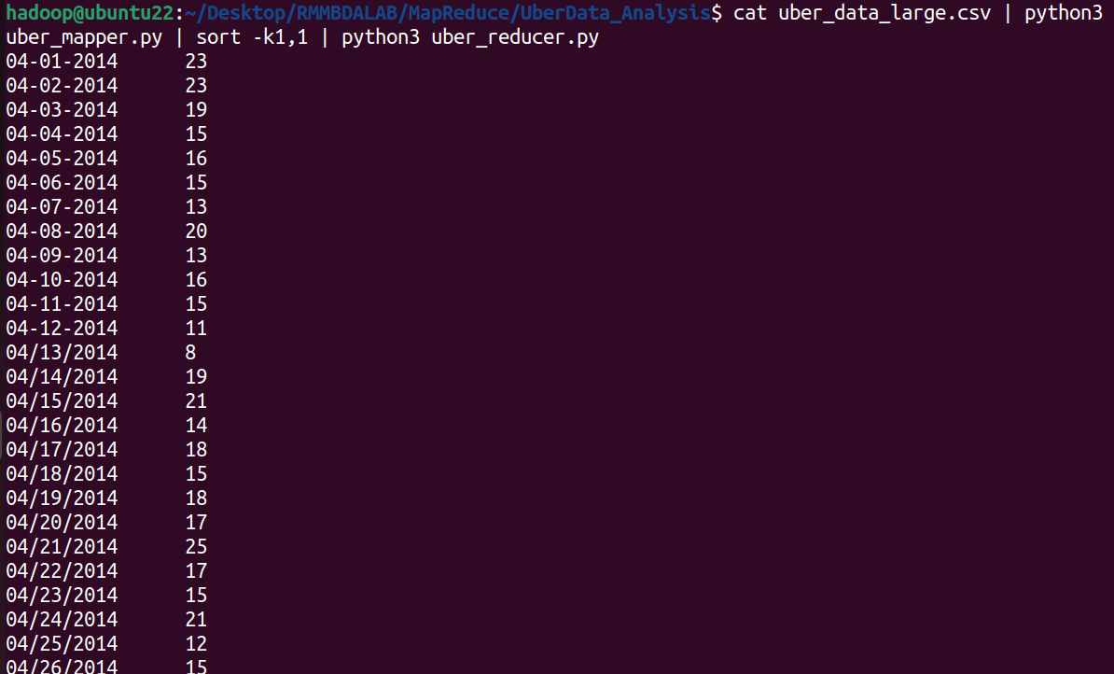
Running on Hadoop Cluster:

hadoop@ubuntu22:~/Desktop/RMMBDALAB/MapReduce/UberData_Analysis$ hadoop fs -put uber_data.csv /rmm_uber_data

hadoop@ubuntu22:~/Desktop/RMMBDALAB/MapReduce/UberData_Analysis$

hadoop fs -put uber_data_large.csv /rmm_uber_data

hadoop@ubuntu22:~/Desktop/RMMBDALAB/MapReduce/UberData_Analysis$ hadoop fs -ls /rmm_uber_data

Found 2 items
-rw-r--r-- 1 hadoop supergroup 862 2025-02-01 12:21 /rmm_uber_data/uber_data.csv
-rw-r--r-- 1 hadoop supergroup 21812 2025-02-01 12:21 /rmm_uber_data/uber_data_large.csv

hadoop@ubuntu22:~/Desktop/RMMBDALAB/MapReduce/UberData_Analysis$

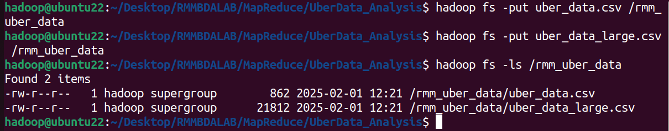

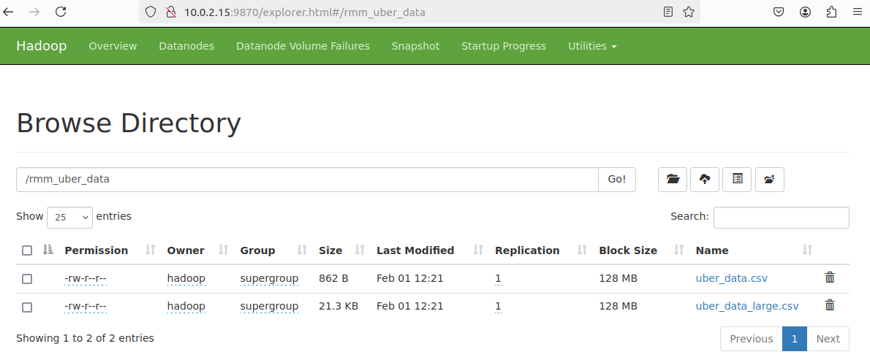

Running on Hadoop Cluster using the file:uber_data.csv

hadoop@ubuntu22:~/Desktop/RMMBDALAB/MapReduce/UberData_Analysis$ hadoop jar /home/hadoop/hadoop/share/hadoop/tools/lib/hadoop-streaming-3.3.6.jar -file uber_mapper.py -mapper "python3 uber_mapper.py" -file uber_reducer.py -reducer "python3 uber_reducer.py" -input /rmm_uber_data/uber_data.csv -output /rmm_uber_data/uber_output1

Job Completion Status:
Output Location:

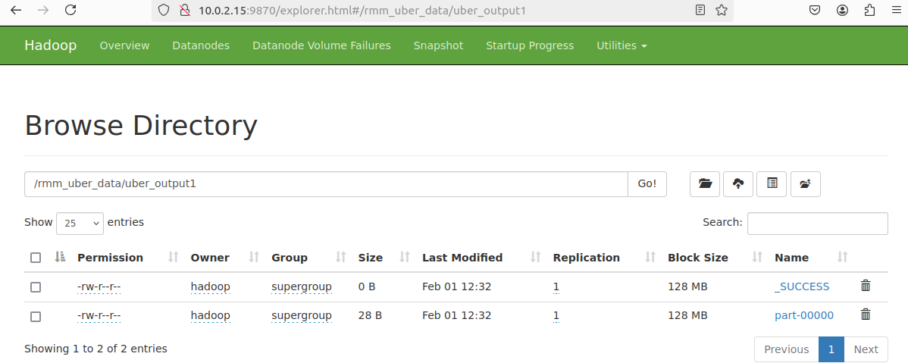
Output:

hadoop@ubuntu22:~/Desktop/RMMBDALAB/MapReduce/UberData_Analysis$ hadoop fs -cat /rmm_uber_data/uber_output1/part-00000

04-01-2014 10
04-02-2014 10

hadoop@ubuntu22:~/Desktop/RMMBDALAB/MapReduce/UberData_Analysis$

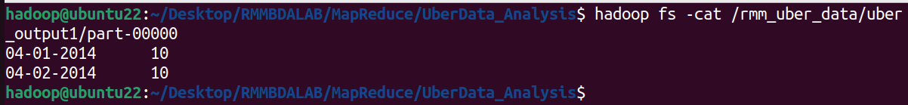
Running on Hadoop Cluster using the file:uber_data_large.csv

hadoop@ubuntu22:~/Desktop/RMMBDALAB/MapReduce/UberData_Analysis$ hadoop jar /home/hadoop/hadoop/share/hadoop/tools/lib/hadoop-streaming-3.3.6.jar -file uber_mapper.py -mapper "python3 uber_mapper.py" -file uber_reducer.py -reducer "python3 uber_reducer.py" -input /rmm_uber_data/uber_data_large.csv -output /rmm_uber_data/uber_output2

Job Completion Status:

Output Location:

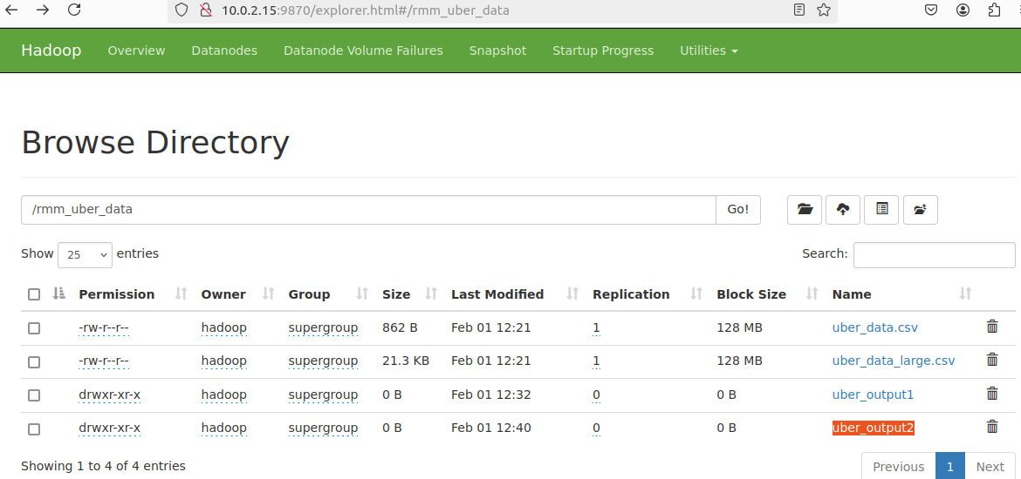
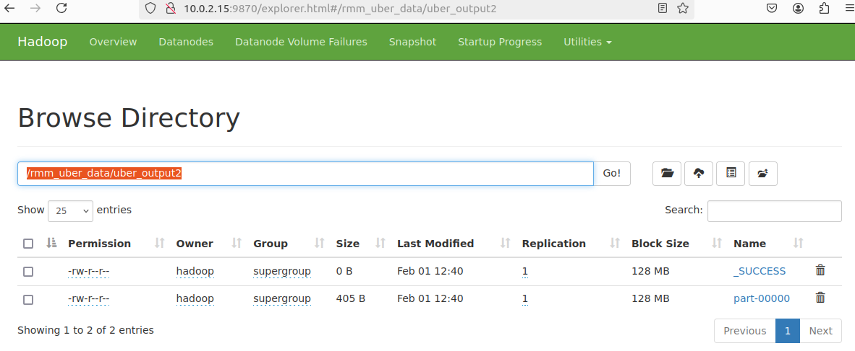
Output:

hadoop@ubuntu22:~/Desktop/RMMBDALAB/MapReduce/UberData_Analysis$ hadoop fs -cat /rmm_uber_data/uber_output2/part-00000

04-01-2014 23
04-02-2014 23
04-03-2014 19
04-04-2014 15
04-05-2014 16
04-06-2014 15
04-07-2014 13
04-08-2014 20
04-09-2014 13
04-10-2014 16
04-11-2014 15
04-12-2014 11
04/13/2014 8
04/14/2014 19
04/15/2014 21
04/16/2014 14
04/17/2014 18
04/18/2014 15
04/19/2014 18
04/20/2014 17
04/21/2014 25
04/22/2014 17
04/23/2014 15
04/24/2014 21
04/25/2014 12
04/26/2014 15
04/27/2014 27
04/28/2014 19
04/29/2014 20

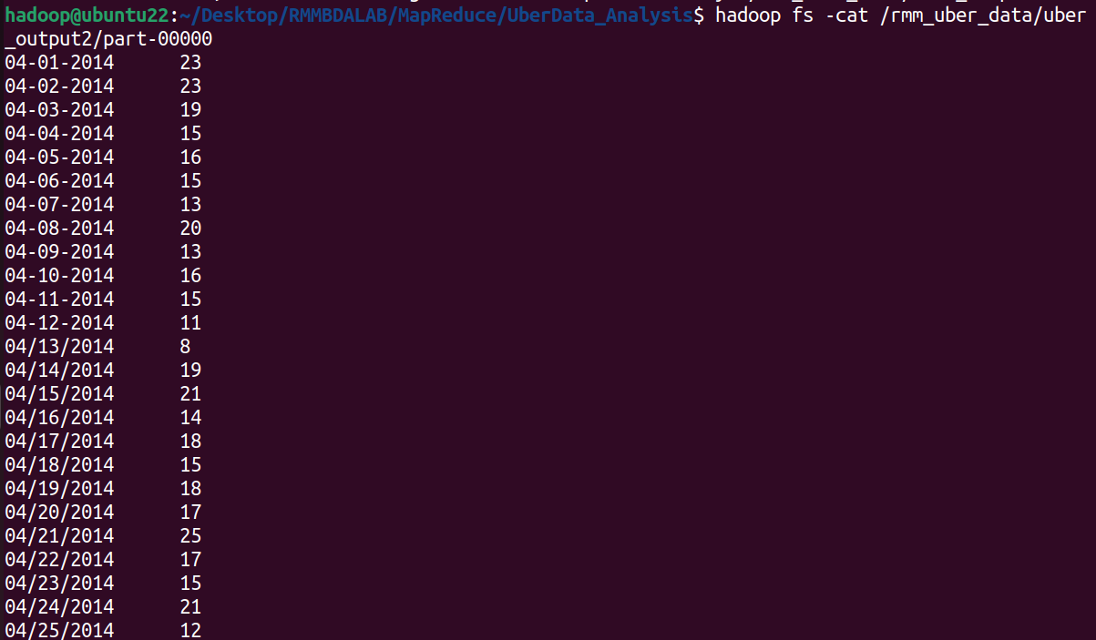

Source Files:

uber_data.csv:

Date/Time,Lat,Lon,Base
04-01-2014 00:11,40.769,-73.9549,B02512
04-01-2014 00:17,40.7267,-74.0345,B02512
04-01-2014 00:21,40.7316,-73.9873,B02512
04-01-2014 00:28,40.7588,-73.9776,B02512
04-01-2014 00:33,40.7594,-73.9722,B02512
04-01-2014 00:33,40.7383,-74.0403,B02512
04-01-2014 00:39,40.7223,-74.0423,B02512
04-01-2014 00:45,40.7505,-73.9946,B02512
04-01-2014 00:45,40.7383,-74.0403,B02512
04-01-2014 00:50,40.7588,-73.9776,B02512
04-02-2014 01:11,40.769,-73.9549,B02513
04-02-2014 01:17,40.7267,-74.0345,B02513
04-02-2014 01:21,40.7316,-73.9873,B02513
04-02-2014 01:28,40.7588,-73.9776,B02513
04-02-2014 01:33,40.7594,-73.9722,B02513
04-02-2014 01:33,40.7383,-74.0403,B02513
04-02-2014 01:39,40.7223,-74.0423,B02513
04-02-2014 01:45,40.7505,-73.9946,B02513
04-02-2014 01:45,40.7383,-74.0403,B02513
04-02-2014 01:50,40.7588,-73.9776,B02513

uber_data_large.csv:

Date/Time,Lat,Lon,Base
04/24/2014 16:48:41,40.6877,-74.0178,B02512
04/15/2014 10:26:04,40.5241,-74.0291,B02515
04-01-2014 17:28,40.5611,-73.85,B02512
04-08-2014 02:08,40.8473,-73.963,B02513
04/14/2014 06:23:53,40.5253,-73.9258,B02514
04/15/2014 13:27:52,40.6855,-73.9205,B02514
04/26/2014 20:48:59,40.7212,-73.8979,B02512
04/25/2014 12:08:14,40.6829,-74.0588,B02515
04/29/2014 09:35:25,40.5232,-73.9532,B02512
04-02-2014 06:10,40.956,-73.7856,B02515
04-02-2014 15:23,40.7856,-73.8671,B02512
04/27/2014 08:33:07,40.5073,-73.9442,B02514
04/21/2014 19:07:30,40.8455,-74.1081,B02513
04/14/2014 16:45:27,40.516,-73.9314,B02514
04/28/2014 08:37:20,40.5665,-74.057,B02514
04/26/2014 08:56:28,40.6487,-73.9026,B02514
04/27/2014 17:06:18,40.568,-74.0578,B02515
04/21/2014 15:35:57,40.9699,-74.1921,B02512
04/15/2014 01:10:40,40.6686,-73.9509,B02514
04/18/2014 17:00:40,40.5659,-73.8371,B02515
04/28/2014 01:19:22,40.7585,-73.8961,B02515
04-02-2014 02:47,40.667,-74.1758,B02512
04/15/2014 13:24:39,40.8934,-73.8296,B02514
04/27/2014 03:42:27,40.8453,-73.8823,B02515
04-04-2014 22:59,40.6884,-74.1241,B02514
04/18/2014 19:49:19,40.9606,-73.7279,B02513
04/19/2014 11:25:53,40.5926,-73.8772,B02512
04-01-2014 08:40,40.9524,-74.06,B02515
04/22/2014 04:40:52,40.812,-73.7741,B02514
04/22/2014 18:12:53,40.5718,-74.0377,B02513
04/27/2014 18:48:59,40.8489,-74.1387,B02514
04/15/2014 11:56:52,40.6863,-74.0866,B02513
04-05-2014 14:21,40.5163,-73.9706,B02513
04-08-2014 10:04,40.8666,-73.72,B02515
04/24/2014 19:53:49,40.6737,-74.0702,B02514
04/26/2014 11:38:48,40.891,-73.781,B02514
04/13/2014 08:28:23,40.8247,-73.8111,B02514
04/20/2014 10:27:17,40.6754,-73.853,B02513
04/22/2014 07:31:26,40.5315,-73.9235,B02515
04/24/2014 09:30:34,40.8565,-74.0751,B02512
04/23/2014 08:04:00,40.8826,-73.7034,B02515
04-12-2014 01:41,40.7854,-73.9798,B02512
04/26/2014 05:53:24,40.919,-73.9436,B02513
04-08-2014 07:45,40.8882,-73.9272,B02515
04/17/2014 17:43:49,40.6766,-74.1806,B02513
04-04-2014 14:35,40.8045,-73.747,B02514
04-02-2014 04:32,40.8907,-73.8936,B02513
04/19/2014 02:11:14,40.8597,-73.8095,B02514
04-10-2014 21:14,40.9146,-74.1342,B02514
04/21/2014 00:53:00,40.6688,-74.1401,B02512
04/20/2014 14:24:08,40.8275,-73.949,B02515
04-05-2014 00:43,40.797,-74.0817,B02513
04-08-2014 23:45,40.9388,-74.0678,B02512
04/21/2014 03:29:00,40.6138,-74.009,B02514
04/26/2014 15:12:41,40.8905,-74.1664,B02513
04/19/2014 19:26:33,40.578,-74.0116,B02515
04-03-2014 15:31,40.6377,-74.0688,B02513
04/14/2014 16:33:25,40.5377,-73.8042,B02514
04/23/2014 14:25:53,40.8215,-74.1294,B02515
04-11-2014 08:24,40.8147,-73.9157,B02515
04-09-2014 09:39,40.8391,-74.0337,B02514
04/21/2014 04:15:51,40.9048,-73.8922,B02514
04/24/2014 16:31:20,40.6937,-73.9248,B02515
04/17/2014 19:37:53,40.866,-74.0152,B02514
04-10-2014 20:39,40.6734,-73.9355,B02514
04/19/2014 04:01:28,40.5795,-73.8384,B02513
04-11-2014 08:05,40.9995,-74.1313,B02515
04/19/2014 00:13:15,40.7365,-74.0086,B02513
04/19/2014 00:02:14,40.5966,-74.1627,B02515
04-06-2014 01:11,40.5926,-74.0552,B02515
04/14/2014 02:20:58,40.7457,-73.7469,B02513
04-02-2014 09:36,40.7328,-74.1964,B02513
04-06-2014 07:32,40.9971,-73.7587,B02513
04/28/2014 19:51:54,40.7636,-73.9738,B02513
04/23/2014 06:47:35,40.9507,-74.0541,B02514
04-05-2014 08:32,40.9892,-73.7627,B02513
04-04-2014 03:04,40.6521,-73.8301,B02515
04-03-2014 12:36,40.6096,-74.1242,B02512
04/28/2014 15:48:24,40.9958,-73.7268,B02512
04/27/2014 21:00:17,40.5845,-74.0721,B02513
04-03-2014 16:19,40.992,-74.0009,B02513
04-03-2014 21:22,40.9179,-73.8502,B02513
04/20/2014 00:47:00,40.5399,-73.8219,B02514
04/20/2014 03:20:42,40.9622,-74.1998,B02514
04/17/2014 22:31:54,40.7909,-73.7243,B02512
04-04-2014 05:49,40.6379,-73.9245,B02512
04/21/2014 15:10:44,40.9305,-74.173,B02515
04/29/2014 08:50:28,40.5038,-74.031,B02515
04/17/2014 16:34:36,40.9021,-74.1136,B02514
04-01-2014 19:36,40.6874,-74.0191,B02513
04/25/2014 00:22:32,40.5249,-74.0614,B02513
04/29/2014 04:58:51,40.8466,-73.8613,B02514
04/13/2014 01:31:03,40.6042,-73.7379,B02514
04-03-2014 03:32,40.7682,-74.0801,B02514
04-10-2014 05:55,40.7378,-74.0297,B02513
04/24/2014 07:22:03,40.8218,-73.9714,B02512
04/27/2014 07:25:46,40.5729,-74.0957,B02513
04-01-2014 14:02,40.5028,-73.9419,B02515
04/18/2014 04:17:57,40.7726,-73.9646,B02514
04-11-2014 13:26,40.6076,-73.8149,B02515
04/27/2014 21:18:03,40.8082,-74.0552,B02512
04/18/2014 05:02:10,40.7029,-73.8149,B02515
04/22/2014 01:25:43,40.8065,-73.702,B02515
04/21/2014 21:10:44,40.5501,-73.8623,B02515
04-09-2014 00:24,40.6167,-73.8168,B02514
04-03-2014 12:48,40.6177,-73.991,B02515
04-11-2014 03:18,40.7854,-73.8413,B02513
04/23/2014 05:03:30,40.9021,-74.0065,B02512
04/20/2014 23:06:31,40.9874,-74.0906,B02512
04/13/2014 04:44:10,40.9759,-73.9795,B02513
04-06-2014 09:37,40.5528,-74.1819,B02515
04-11-2014 09:21,40.9644,-73.9707,B02512
04-04-2014 09:30,40.7221,-73.9287,B02515
04-05-2014 07:54,40.5741,-74.1847,B02514
04-04-2014 15:54,40.9424,-74.1423,B02513
04/21/2014 17:32:57,40.952,-74.0802,B02515
04/17/2014 22:55:22,40.8681,-74.0086,B02512
04-12-2014 16:15,40.6184,-73.8384,B02512
04/17/2014 13:58:49,40.6666,-74.0454,B02515
04-05-2014 09:40,40.5413,-73.928,B02513
04/21/2014 15:40:57,40.8085,-74.0751,B02514
04/15/2014 20:44:34,40.9384,-73.9377,B02513
04/21/2014 23:22:00,40.7197,-74.096,B02513
04/19/2014 20:18:51,40.693,-74.0812,B02513
04-02-2014 04:38,40.5426,-73.8016,B02512
04/21/2014 12:14:44,40.7905,-74.1293,B02512
04/13/2014 00:15:32,40.8346,-74.1544,B02515
04/23/2014 04:53:07,40.5577,-73.919,B02514
04-07-2014 08:46,40.6516,-73.7987,B02513
04-02-2014 01:28,40.8104,-73.8517,B02512
04-05-2014 00:58,40.7687,-74.0038,B02513
04/19/2014 05:49:01,40.9634,-73.8741,B02513
04/27/2014 13:58:08,40.5334,-74.019,B02513
04-01-2014 23:22,40.7411,-74.0858,B02515
04/16/2014 11:29:27,40.8827,-73.9564,B02514
04/27/2014 21:12:56,40.7731,-74.1849,B02512
04/16/2014 18:57:47,40.6842,-73.7825,B02515
04-07-2014 01:21,40.6981,-73.9371,B02512
04-05-2014 02:56,40.5763,-73.734,B02514
04/14/2014 23:45:54,40.8688,-74.071,B02512
04-08-2014 22:06,40.9466,-74.1829,B02515
04/28/2014 17:34:00,40.7225,-73.866,B02513
04-02-2014 23:03,40.9687,-73.7908,B02515
04-07-2014 00:29,40.7285,-73.8987,B02514
04-12-2014 23:44,40.5848,-73.9946,B02512
04-05-2014 15:40,40.8101,-73.7436,B02514
04/15/2014 00:07:01,40.7411,-73.8655,B02514
04-04-2014 22:00,40.995,-73.7262,B02512
04/28/2014 18:39:07,40.5223,-74.0927,B02513
04/28/2014 13:39:59,40.778,-74.0563,B02513
04-11-2014 11:33,40.6506,-74.1022,B02513
04/24/2014 08:20:43,40.8299,-73.9885,B02512
04-11-2014 11:52,40.6887,-74.1229,B02515
04-01-2014 23:02,40.663,-74.141,B02512
04-06-2014 15:33,40.9207,-74.0618,B02513
04-02-2014 12:29,40.7709,-73.8096,B02515
04/25/2014 13:17:07,40.5917,-73.7703,B02514
04-05-2014 11:34,40.5961,-74.0286,B02512
04-02-2014 08:30,40.8244,-73.8449,B02513
04/16/2014 23:34:25,40.6221,-74.0947,B02513
04-06-2014 03:23,40.5104,-74.0914,B02514
04/16/2014 19:47:16,40.7177,-73.8111,B02512
04-08-2014 03:29,40.6877,-74.1335,B02515
04/20/2014 07:48:41,40.7291,-74.0594,B02512
04-02-2014 01:09,40.6593,-74.0511,B02512
04/21/2014 13:42:28,40.8922,-73.7973,B02514
04/21/2014 01:35:27,40.8909,-73.9501,B02514
04/29/2014 22:20:38,40.8838,-73.9264,B02512
04-01-2014 23:03,40.5039,-74.0594,B02515
04-10-2014 06:52,40.5056,-74.1564,B02514
04-08-2014 05:44,40.727,-74.158,B02512
04/20/2014 17:43:27,40.6255,-73.786,B02512
04/22/2014 15:14:55,40.5912,-74.1154,B02514
04/14/2014 15:59:35,40.6359,-73.9398,B02513
04/14/2014 14:00:54,40.5455,-74.1267,B02515
04/27/2014 16:19:48,40.918,-73.7554,B02515
04-09-2014 23:40,40.8312,-73.9354,B02514
04/20/2014 12:18:57,40.8679,-73.7419,B02512
04/27/2014 08:53:28,40.5533,-74.1028,B02515
04-08-2014 02:46,40.6379,-73.8149,B02512
04/28/2014 11:16:44,40.6856,-73.7859,B02515
04/21/2014 18:38:03,40.5768,-73.8167,B02514
04/16/2014 15:57:06,40.5275,-73.8521,B02512
04/23/2014 03:13:04,40.7888,-73.9016,B02515
04-06-2014 01:41,40.8385,-73.8389,B02515
04/19/2014 18:11:57,40.816,-73.7149,B02512
04/28/2014 02:45:27,40.7482,-73.768,B02512
04/15/2014 17:47:39,40.6256,-73.7138,B02515
04-12-2014 18:21,40.6888,-73.7353,B02515
04/14/2014 16:16:54,40.7184,-73.9149,B02514
04/18/2014 19:10:13,40.5074,-74.0482,B02513
04/25/2014 05:37:59,40.8424,-73.8869,B02513
04/25/2014 02:58:24,40.7226,-73.865,B02513
04/21/2014 08:52:58,40.9818,-73.7977,B02515
04-05-2014 00:13,40.6347,-73.7284,B02514
04/19/2014 16:45:35,40.5697,-73.9707,B02514
04-09-2014 11:52,40.6699,-74.0193,B02513
04-10-2014 04:36,40.9445,-74.0374,B02514
04/19/2014 17:41:31,40.8788,-74.198,B02514
04/23/2014 10:47:18,40.6739,-74.0409,B02514
04/24/2014 14:19:49,40.6293,-74.069,B02515
04/17/2014 22:05:52,40.934,-73.7974,B02515
04-03-2014 13:43,40.9993,-73.8261,B02515
04/18/2014 07:37:29,40.5753,-73.9894,B02514
04-03-2014 15:30,40.8276,-74.0348,B02512
04/23/2014 02:24:55,40.9694,-74.0086,B02512
04/22/2014 08:55:33,40.8128,-74.1729,B02514
04/29/2014 06:01:45,40.9069,-74.1075,B02515
04/20/2014 04:47:37,40.5799,-74.1288,B02515
04-10-2014 19:57,40.9594,-74.0029,B02512
04-04-2014 20:40,40.7155,-73.9311,B02513
04-12-2014 13:12,40.7897,-73.8568,B02512
04/13/2014 19:16:26,40.9997,-73.7246,B02513
04/18/2014 22:11:52,40.7245,-74.1665,B02512
04-10-2014 07:41,40.8527,-73.8106,B02513
04-08-2014 05:38,40.5488,-74.0779,B02513
04/21/2014 20:49:05,40.7856,-73.9142,B02515
04-07-2014 07:05,40.5085,-73.7341,B02512
04/14/2014 05:55:38,40.739,-74.1165,B02512
04/29/2014 17:32:00,40.6438,-74.1063,B02515
04/24/2014 09:57:24,40.6121,-73.9737,B02515
04-01-2014 21:24,40.6894,-73.9862,B02514
04-05-2014 22:15,40.7919,-74.0363,B02515
04-01-2014 08:50,40.927,-73.7294,B02515
04/17/2014 07:55:26,40.8711,-74.0763,B02514
04-07-2014 22:08,40.9507,-74.1202,B02512
04/15/2014 17:26:23,40.8555,-73.8491,B02512
04-03-2014 20:57,40.5831,-73.7033,B02512
04-04-2014 15:41,40.8817,-74.0382,B02513
04-05-2014 01:39,40.9217,-74.1262,B02512
04-09-2014 08:47,40.7614,-74.1866,B02515
04/29/2014 08:28:35,40.762,-73.8099,B02515
04/17/2014 16:22:15,40.9192,-73.7757,B02514
04-06-2014 12:53,40.5747,-73.7123,B02512
04-11-2014 00:37,40.8405,-73.8115,B02513
04/24/2014 01:48:20,40.8078,-74.1174,B02512
04-09-2014 04:00,40.9455,-74.0306,B02512
04/28/2014 09:06:47,40.712,-74.0456,B02515
04-11-2014 07:07,40.5853,-73.9676,B02513
04/26/2014 04:01:14,40.8114,-74.0578,B02514
04/18/2014 01:47:12,40.9333,-74.0007,B02513
04-09-2014 05:10,40.8174,-74.0429,B02512
04/18/2014 01:12:18,40.6103,-74.1833,B02513
04/19/2014 02:54:41,40.6907,-73.7867,B02513
04/24/2014 19:18:37,40.7805,-74.0077,B02514
04/14/2014 08:09:45,40.9271,-73.8392,B02514
04/21/2014 06:45:59,40.6003,-74.1438,B02514
04-11-2014 01:40,40.6246,-74.1175,B02512
04-11-2014 05:51,40.6479,-73.8814,B02515
04/18/2014 22:56:18,40.6331,-73.9628,B02512
04-09-2014 00:29,40.7331,-73.7714,B02514
04/29/2014 06:55:30,40.7673,-74.0053,B02512
04/19/2014 14:01:21,40.9959,-73.8497,B02514
04/18/2014 22:42:56,40.6623,-73.7333,B02515
04-02-2014 17:50,40.7382,-74.0709,B02514
04/26/2014 06:13:01,40.892,-73.9647,B02513
04/15/2014 15:43:08,40.9433,-74.1585,B02514
04/23/2014 07:19:12,40.584,-73.8867,B02514
04-01-2014 05:26,40.6443,-74.0541,B02515
04/24/2014 07:18:08,40.7401,-73.7638,B02514
04/14/2014 11:44:24,40.896,-74.0086,B02513
04/24/2014 17:45:05,40.6641,-73.8051,B02513
04/25/2014 01:23:18,40.9327,-73.7014,B02512
04/15/2014 10:33:58,40.5208,-73.9226,B02514
04/14/2014 09:50:59,40.538,-74.1757,B02513
04-01-2014 08:09,40.8403,-73.886,B02513
04-03-2014 16:14,40.9735,-74.0346,B02513
04/19/2014 19:51:48,40.518,-73.8898,B02513
04-04-2014 00:19,40.9043,-73.9422,B02513
04/20/2014 14:41:39,40.954,-74.0067,B02513
04/16/2014 14:08:39,40.6998,-74.1725,B02512
04/28/2014 20:36:00,40.9371,-74.044,B02512
04/20/2014 09:18:54,40.5604,-74.0732,B02512
04-11-2014 00:18,40.9978,-74.0872,B02513
04-03-2014 23:51,40.6456,-73.7341,B02512
04-03-2014 09:43,40.8179,-73.9184,B02512
04/21/2014 18:54:45,40.6417,-73.8911,B02512
04/17/2014 12:01:54,40.9412,-74.1222,B02512
04/23/2014 08:46:06,40.6259,-73.9514,B02512
04-09-2014 04:38,40.7043,-73.7916,B02513
04-07-2014 19:06,40.5601,-73.9781,B02514
04/19/2014 06:34:49,40.5874,-73.8796,B02512
04-10-2014 13:31,40.6053,-73.9854,B02514
04/15/2014 23:58:27,40.643,-73.9272,B02515
04/14/2014 11:06:06,40.9363,-73.8917,B02514
04/26/2014 01:45:20,40.5098,-74.0019,B02514
04-07-2014 12:37,40.6991,-74.1124,B02514
04/22/2014 07:26:44,40.7623,-73.9666,B02513
04-02-2014 06:55,40.6666,-74.0378,B02512
04-07-2014 06:20,40.9862,-73.9945,B02515
04/28/2014 06:57:31,40.6407,-74.136,B02515
04-05-2014 06:01,40.9321,-73.8369,B02513
04-05-2014 12:12,40.7629,-73.8763,B02515
04/27/2014 02:05:24,40.5061,-74.1451,B02514
04-05-2014 03:21,40.9457,-73.9161,B02514
04/24/2014 13:39:59,40.975,-74.0317,B02513
04/23/2014 02:59:37,40.9103,-73.8954,B02514
04/18/2014 16:08:43,40.7636,-73.9691,B02512
04/18/2014 17:19:39,40.7158,-74.0972,B02513
04-01-2014 18:12,40.7778,-73.8892,B02514
04/17/2014 11:09:26,40.6269,-74.1719,B02512
04-10-2014 19:52,40.7746,-74.0593,B02515
04-01-2014 05:33,40.695,-74.1435,B02515
04/27/2014 18:55:41,40.6946,-73.9586,B02512
04-10-2014 16:43,40.8259,-74.0185,B02514
04-01-2014 18:49,40.8235,-73.9856,B02513
04/22/2014 16:31:54,40.9644,-74.0836,B02514
04-06-2014 05:39,40.5843,-74.0338,B02513
04/21/2014 19:26:21,40.928,-74.016,B02514
04/27/2014 23:50:36,40.6715,-73.9178,B02514
04/27/2014 15:38:52,40.9083,-74.1951,B02512
04/27/2014 14:12:51,40.8912,-73.9226,B02513
04-08-2014 15:43,40.8133,-73.7354,B02512
04-09-2014 22:57,40.6822,-74.1274,B02515
04-07-2014 16:31,40.7565,-74.1904,B02515
04/29/2014 01:54:41,40.5354,-74.0238,B02513
04-06-2014 01:45,40.7661,-73.9471,B02512
04/29/2014 20:02:05,40.7993,-73.9219,B02512
04-05-2014 22:42,40.5424,-73.7829,B02515
04-08-2014 00:03,40.9714,-73.846,B02515
04-06-2014 03:03,40.7529,-73.7493,B02512
04/17/2014 22:04:36,40.8024,-74.0438,B02514
04/23/2014 19:39:47,40.7425,-73.8804,B02514
04/19/2014 06:30:06,40.5832,-73.9407,B02515
04/26/2014 16:12:15,40.7405,-73.7,B02513
04/29/2014 03:33:15,40.8126,-73.9244,B02513
04/21/2014 13:24:34,40.7509,-73.8768,B02515
04/15/2014 06:03:37,40.518,-74.1933,B02513
04/15/2014 16:16:24,40.9226,-74.1563,B02514
04-09-2014 15:52,40.955,-74.1249,B02514
04-07-2014 05:52,40.7775,-73.9399,B02512
04-03-2014 23:50,40.59,-74.1835,B02512
04/15/2014 09:41:39,40.5148,-73.7945,B02515
04/28/2014 09:15:43,40.8558,-73.8979,B02515
04/13/2014 10:59:57,40.8715,-74.133,B02514
04/16/2014 17:54:58,40.6148,-73.9827,B02513
04/17/2014 07:28:36,40.7809,-74.0121,B02514
04/26/2014 01:27:23,40.7144,-74.0006,B02514
04/13/2014 03:56:11,40.6306,-73.9197,B02513
04-08-2014 06:43,40.9322,-73.8792,B02513
04-04-2014 03:11,40.8627,-73.7237,B02513
04-01-2014 15:02,40.5018,-73.7734,B02515
04/21/2014 17:28:17,40.7967,-73.7576,B02515
04/29/2014 12:34:53,40.5157,-73.8513,B02514
04-01-2014 09:46,40.7221,-73.7396,B02513
04/16/2014 09:30:51,40.8277,-74.1252,B02512
04/13/2014 06:03:39,40.707,-74.1951,B02513
04/28/2014 12:22:59,40.931,-73.7205,B02515
04-06-2014 00:39,40.5418,-73.7656,B02514
04/23/2014 11:23:32,40.9344,-74.0859,B02514
04/17/2014 15:33:16,40.9549,-73.7577,B02513
04/21/2014 17:32:44,40.5913,-73.9941,B02515
04-06-2014 04:50,40.5249,-74.1196,B02515
04-12-2014 06:53,40.7354,-73.8916,B02515
04/15/2014 10:59:33,40.6322,-74.0025,B02512
04/16/2014 06:21:31,40.5617,-74.098,B02512
04-08-2014 15:08,40.829,-74.1617,B02515
04/15/2014 11:26:42,40.5068,-73.8233,B02515
04/24/2014 12:57:37,40.7029,-73.8287,B02513
04-08-2014 02:33,40.8544,-73.8766,B02515
04/23/2014 04:08:55,40.7667,-73.7002,B02512
04/20/2014 13:59:15,40.7958,-73.9765,B02515
04-12-2014 21:14,40.5634,-73.8351,B02515
04/18/2014 16:51:40,40.57,-73.9729,B02512
04/29/2014 00:21:38,40.6309,-74.1703,B02514
04-03-2014 08:58,40.7851,-74.0355,B02514
04/15/2014 03:47:12,40.936,-74.0835,B02512
04-02-2014 04:12,40.5327,-74.0162,B02515
04/20/2014 06:47:28,40.6317,-73.7389,B02515
04/18/2014 19:40:50,40.8588,-73.7435,B02513
04/24/2014 05:51:17,40.5473,-74.0442,B02514
04-11-2014 16:21,40.7369,-74.0348,B02512
04-10-2014 12:24,40.6478,-73.8923,B02514
04/15/2014 15:13:43,40.9606,-73.9108,B02513
04-02-2014 18:37,40.8188,-73.915,B02514
04/17/2014 00:25:16,40.7734,-73.9497,B02512
04/27/2014 13:44:50,40.757,-73.8494,B02512
04/22/2014 04:14:56,40.8931,-74.043,B02514
04-09-2014 08:46,40.5827,-74.0321,B02514
04-11-2014 03:00,40.6574,-73.9275,B02512
04/24/2014 22:37:57,40.972,-73.8053,B02513
04-10-2014 21:41,40.9368,-73.8975,B02514
04/14/2014 20:43:24,40.7059,-73.8544,B02514
04/28/2014 01:17:02,40.7008,-73.7481,B02514
04-11-2014 03:16,40.9957,-73.8113,B02514
04/26/2014 22:03:54,40.5505,-74.1669,B02513
04-10-2014 21:18,40.9528,-73.9453,B02513
04/14/2014 04:12:50,40.8828,-73.7876,B02515
04/24/2014 08:17:50,40.5908,-73.8267,B02512
04/16/2014 04:38:51,40.6183,-73.7866,B02512
04-04-2014 10:23,40.7993,-73.9661,B02512
04/26/2014 12:47:16,40.5629,-74.1812,B02514
04-02-2014 18:05,40.944,-73.8347,B02515
04-06-2014 18:20,40.8927,-73.7144,B02515
04/24/2014 18:00:03,40.7901,-73.7053,B02512
04/27/2014 11:11:51,40.5013,-73.8435,B02513
04/26/2014 22:09:36,40.7734,-74.0769,B02513
04/16/2014 03:10:36,40.5022,-73.8083,B02512
04/29/2014 18:25:15,40.5398,-73.9425,B02515
04-12-2014 03:21,40.864,-74.1084,B02512
04/28/2014 08:52:01,40.6729,-74.0856,B02512
04-08-2014 12:03,40.9004,-73.7445,B02514
04/26/2014 02:57:06,40.8887,-73.9719,B02514
04-04-2014 04:33,40.664,-73.8562,B02512
04-10-2014 11:15,40.9322,-73.9647,B02514
04/27/2014 11:47:57,40.6882,-73.8985,B02514
04/27/2014 07:01:38,40.9787,-74.1093,B02512
04/15/2014 10:40:11,40.7916,-74.1074,B02513
04/29/2014 12:15:46,40.707,-73.798,B02513
04/22/2014 09:40:43,40.8453,-73.9864,B02514
04-02-2014 05:46,40.7693,-74.0087,B02514
04/24/2014 03:27:01,40.927,-73.9077,B02512
04/27/2014 23:45:41,40.9252,-73.9259,B02512
04/20/2014 16:06:10,40.6508,-73.9523,B02513
04/14/2014 03:32:05,40.5942,-74.0616,B02513
04-01-2014 14:29,40.6103,-73.837,B02515
04-02-2014 20:46,40.5863,-73.7115,B02513
04/21/2014 18:00:35,40.8541,-74.0804,B02512
04/17/2014 06:36:42,40.6804,-73.8117,B02513
04-04-2014 22:39,40.6137,-73.9859,B02514
04-08-2014 16:47,40.9223,-73.7038,B02512
04/27/2014 16:59:52,40.6686,-73.8141,B02512
04/25/2014 17:38:30,40.6817,-74.093,B02515
04/19/2014 09:24:12,40.6579,-74.0446,B02513
04/16/2014 12:50:16,40.9405,-73.8424,B02514
04/22/2014 16:06:01,40.5592,-73.7433,B02514
04-08-2014 05:51,40.9122,-74.0365,B02515
04/29/2014 01:40:16,40.522,-73.8327,B02515
04-10-2014 15:42,40.9804,-73.9079,B02515
04/27/2014 20:03:55,40.8458,-74.1343,B02513
04/25/2014 04:32:25,40.9869,-73.7817,B02513
04-08-2014 18:56,40.81,-73.9478,B02513
04-03-2014 21:50,40.8745,-74.1314,B02514
04-12-2014 14:22,40.6974,-73.7225,B02512
04-02-2014 22:53,40.7259,-73.8338,B02514
04-07-2014 22:20,40.7142,-74.1663,B02515
04/22/2014 06:33:58,40.7812,-73.9091,B02513
04/27/2014 19:02:04,40.5656,-73.71,B02512
04/25/2014 01:54:03,40.7785,-73.9117,B02514
04/29/2014 16:13:26,40.9055,-73.727,B02515
04/17/2014 08:27:39,40.6847,-74.1601,B02515
04/29/2014 04:07:56,40.8288,-73.9165,B02513
04-04-2014 20:37,40.7044,-73.7822,B02514
04/20/2014 15:50:11,40.6697,-73.8901,B02514
04/24/2014 14:55:43,40.8029,-74.1674,B02513
04/22/2014 08:38:14,40.5728,-74.1648,B02514
04/28/2014 14:08:07,40.766,-74.0108,B02515
04/28/2014 05:49:54,40.9244,-73.7035,B02515
04-02-2014 19:49,40.9203,-73.9187,B02512
04-02-2014 22:51,40.9863,-74.0199,B02513
04/16/2014 12:35:01,40.7841,-74.0764,B02515
04-03-2014 20:18,40.6647,-73.827,B02515
04-03-2014 03:05,40.9594,-74.1354,B02515
04-08-2014 22:27,40.5733,-73.9446,B02513
04/21/2014 01:01:42,40.6138,-73.9771,B02512
04-01-2014 10:28,40.5405,-73.8424,B02512
04/27/2014 12:59:17,40.5156,-73.7347,B02515
04-02-2014 12:03,40.7034,-73.7342,B02513
04/23/2014 22:05:47,40.8211,-73.9109,B02514
04-06-2014 22:54,40.7025,-74.1487,B02513
04-01-2014 09:54,40.7241,-74.0993,B02512
04-03-2014 13:14,40.5265,-73.7178,B02512
04/27/2014 14:58:03,40.8465,-74.0045,B02513
04/16/2014 10:39:33,40.757,-74.0154,B02512
04/22/2014 21:30:29,40.9009,-73.9546,B02513
04/24/2014 03:57:35,40.6816,-73.7003,B02512
04/29/2014 19:45:35,40.9658,-74.0983,B02512
04-07-2014 01:40,40.522,-73.7194,B02512
04-08-2014 11:58,40.8643,-74.1018,B02512
04/26/2014 23:14:45,40.8313,-74.1609,B02512
04-06-2014 08:38,40.5602,-74.0786,B02512
04-12-2014 03:00,40.8874,-73.8427,B02515
04/22/2014 05:43:31,40.6295,-74.0366,B02514
04/27/2014 21:12:45,40.9313,-73.7434,B02513
04-01-2014 14:08,40.928,-73.9761,B02513
04-12-2014 20:25,40.9,-73.8524,B02514
04/14/2014 20:15:24,40.8198,-73.8331,B02514
04-10-2014 23:26,40.5068,-73.8946,B02515
04/19/2014 18:06:14,40.816,-73.8509,B02513
04/20/2014 15:36:01,40.7424,-74.0097,B02513
04-02-2014 12:16,40.8858,-73.9467,B02515
04-07-2014 21:32,40.6463,-73.9966,B02514
04-09-2014 20:48,40.767,-73.8232,B02515
04/17/2014 18:04:31,40.5598,-73.8258,B02514
04/28/2014 09:14:07,40.9399,-74.1232,B02515
04-03-2014 17:49,40.7806,-73.8727,B02513
04/15/2014 18:34:43,40.841,-73.8296,B02513
04-01-2014 07:52,40.9289,-73.7722,B02513
04/25/2014 08:40:57,40.7318,-73.9945,B02515
04-01-2014 03:36,40.7177,-73.7248,B02514
04/14/2014 10:35:01,40.8402,-73.7754,B02513
04-01-2014 21:00,40.6347,-74.0943,B02514
04/25/2014 18:52:08,40.5007,-73.9081,B02512
04/20/2014 00:51:45,40.981,-73.9549,B02512
04/22/2014 03:05:32,40.5697,-74.0923,B02512
04/22/2014 20:08:54,40.6101,-73.8067,B02515
04/21/2014 22:33:25,40.6768,-73.9778,B02514
04/14/2014 13:40:08,40.8705,-74.0656,B02515
04/25/2014 01:06:24,40.8899,-73.7656,B02515
04/29/2014 06:22:56,40.7681,-73.9266,B02514

Mapper Python Code: uber_mapper.py

import sys
import csv

def mapper():
for line in sys.stdin:
line = line.strip()
data = list(csv.reader([line]))[0]

# Skip lines that don't have the expected number of columns
if len(data) < 4:
continue

# Skip header row
if data[0].lower() == 'date/time':
continue

# Extract the date part from the Date/Time column
date_time = data[0]
date = date_time.split(' ')[0] # Get the date part (before the space)

print(f"{date}\t1")

if __name__ == "__main__":
mapper()

Reducer Python Code: uber_reducer.py

import sys

def reducer():
current_date = None
current_count = 0

for line in sys.stdin:
line = line.strip()
date, count = line.split('\t')

try:
count = int(count)
except ValueError:
continue

if current_date == date:
current_count += count
else:
if current_date is not None:
print(f"{current_date}\t{current_count}")
current_date = date
current_count = count

# Output the count for the last date
if current_date is not None:
print(f"{current_date}\t{current_count}")

if __name__ == "__main__":
reducer()

